

GSRS 3.0.3 Release Notes

Dec 2022

Table Contents

Overview: 2

Highlighted New Features 3

New Feature: Exports Pipeline Rework 3

Major Improvement: Substance Selector 5

Major Improvement: Structure Rendering 7

New Feature: Bulk Search 8

New Feature: UTF8 & HTML Name 10

New Feature: Frontend DRY allowing custom styling 11

Other Issues Addressed 12

Improvement: Lucene Upgrade 12

Improvement: Improved auto-generated SQL indexes 12

Other selected Improvements: 13

# Overview:

GSRS 3.0.3 software release is a maintenance release which includes user enhancements, registration enhancements and developer enhancements.

Highlighted new features include:

* Exports Pipeline Rework
* Improved Substance Selector
* Bulk search
* UTF8 & HTML Name
* Structure rendering improvements
* Frontend DRY allowing custom styling

Highlighted improvements and bug fixes include:

* Lucene Upgrade
* Improved auto-generated SQL indexes

# Highlighted New Features

## New Feature: Exports Pipeline Rework

Allows a user to specify parameters for the data scrubber,  record expander and the specific exporter selected.
For example, you can elect to remove Notes from substance records

Figure 1 – Full Export Options Dialog

**Purpose and Motivation:**

Data export has been reworked as of GSRS 3.0.3 to provide the following benefits

* Added flexibility in configuring what data goes into an export
* The ability to remove selected parts of data records
* Optional inclusion of related records (for example, automatically add components to the export when requesting export of a mixture)
* Save selected sets of options for reuse

Note that for 3.0.3, the new options apply only to substances.

**How it works:**

When browsing records, the Export button appears as before. It initially brings up a list of available export file formats. [The ‘Include Private Data’ checkbox has been removed because the next dialog provides a comprehensive set of selections to restrict private data.]

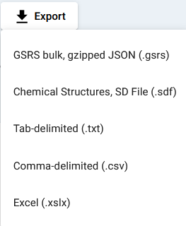

Figure 2-Export File Formats

After you click on one of the file formats, the export options dialog appears.

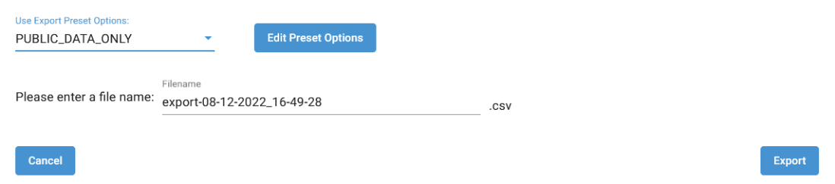

Figure 3-Export Options Dialog

You can select one of the existing Export Preset Options in the list or else click on the Edit Preset Options button.

The edit Preset Options dialog allows you to change:

* Scrubber options that restrict the parts of data record that are included in the exported data.
* Expander options that allow you to specify how additional records may be included with the export.
* Exporter options that are specific to the selected file format.
  + Currently, the only available selections here are for SD file. You can choose whether include names and codes.

The set of options that may be included is long, especially for the scrubber. Look for a future document from the GSRS team with additional information.

**Notes for the future:**

In the future, the GSRS will consider the following

* More documentation the export process, including the specific options available.
* Adding more options to existing exporters
* Extending the options to other entities

## Major Improvement: Substance Selector

**Purpose and Motivation:**

The GSRS team received lots of feedback on ways to speed up and improve quality of life while registering using GSRS. For that purpose, we’ve made several improvements to the way related substances can be searched for and selected in the substance and other entity forms, most notably the ability to search for a substance by structure or name and populate the form with a result, without leaving the registration page.

**How it works:**

When registering or editing a related substance field, like those found in relationships, structural modifications, etc., users should now notice new buttons to search by name or structure.

Figure 4 Search by Name or Structure

Clicking on `Structure Search` will bring up a dialog window with a structure search function. If a substance is already selected it will prepopulate the structure canvas. You can switch between name and structure search using the dialog tabs.

Figure 5-The Substance Selector Structure Search Dialog Box

Figure 5 - The Substance Selector Structure Search Dialog Box

Figure 6 - Search results from the substance selector

Clicking on ‘select’ will set that as the field’s related substance. Once a substance is selected, you can also now click on its icon for a larger image, more information, and links to that records details and edit page.

Figure 7 - related substance information dialog after clicking structure image.

**Notes for the Future:**

We plan on adding further enhancements to selecting relationships, such as the ability to pre-populate fields with set values for fields with repeat related substances, as well as quality of life enhancements for other more time-consuming aspects of registration.

## Major Improvement: Structure Rendering

**Purpose and Motivation:**

The GSRS team received multiple requests to make structures fill the available space without excess padding around the generated image. We have added options to our structure rendering endpoint.

**How it works:**

The aspect of structure rendering discussed here presumes we are starting with a connection table that includes atomic coordinates. (GSRS *can* generate coordinates for a SMILES string but that process has not changed.)

Structure images are sized according to some new parameters:

* **minWidth**
* **minHeight**
* **maxWidth**
* **maxHeight**
* **bondLength**

**minWidth** and **minHeight** define the smallest rectangle that can contain the image to be generated.

**maxWidth** and **maxHeight** define the largest rectangle that can contain the image to be generated.

Rendering works as follows:

* First, the average bond length of the input structure and spread of atomic coordinates in the X and Y dimensions are calculated.
* A scale factor is calculated by dividing the input bond length by the calculated average bond length.
* The scale factor is applied to the calculated X and Y spreads to generate scaled X and scaled Y.
* If the scaled X is greater than maxWidth, scaled X is set to maxWidth.
* If the scaled X is less than minWidth, scaled X is set to maxWidth.
* If the scaled Y is greater than maxHeight, scaled Y is set to maxHeight.
* If the scaled Y is less than minHeight, scaled Y is set to maxHeight.
* Finally, scaled X and scaled Y are used as the bounds of a box into which the structure is drawn.
  + If the structure contains any text (such as optical activity) to be rendered below the molecule, the atoms and bonds are scaled again to leave room for the text.

**Notes for the Future:**

The team will investigate additional improvements to structure rendering in future releases of the software, such as adjusting the position of S-Group brackets.

## New Feature: Bulk Search

**Purpose and Motivation:**

The bulk search feature enables users to make a large set of queries on the substances. User can input the bulk search queries in the input fields or using a file. The query list can still be edited after a search. This feature is currently available in Substance search only.

**How it works:**

Users can get the bulk search menu from the hamburger menu icon as showed in Figure 8 or from “search” menu as showed in Figure 9. The queries can be set in the query field, one query string per line. Another option is to save the queries in a text file, one query per line. Then load the file by clicking on the “Choose File” button.

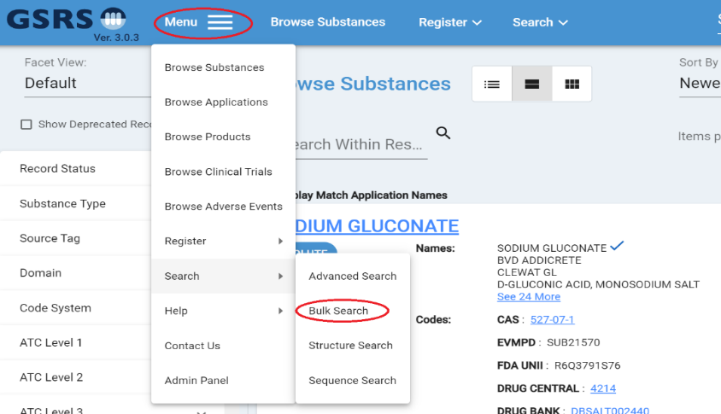

Figure 8 - bulk search from menu

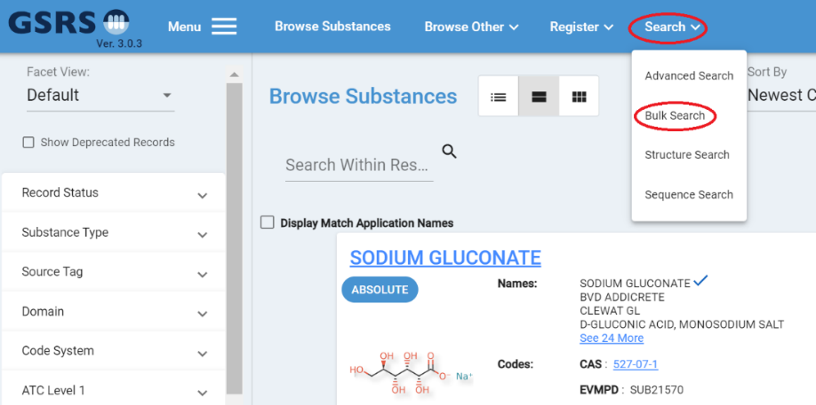

Figure 9 - Bulk search from Search Pull Down Menu

There are two search options: “Identifiers” and “All Fields”. With “Identifiers”, users can use the values of the identifiers defined in your config file in field “ix.core.exactsearchfields” as query strings. For example, if "root_names_stdName" and "root_uuid" are listed in your config file, you can search with standard names and UUID as the query string to get the expected search results. For these identifier values, do exact match searches are performed. Figure 10 shows several example queries. The queries strings include approved ID, UUID, and name of substances. With “All Fields”, users can query with more complexed query strings in all fields. Figure 11 shows an example of searching in all fields. Users can specify field names and use wildcards in the query strings.

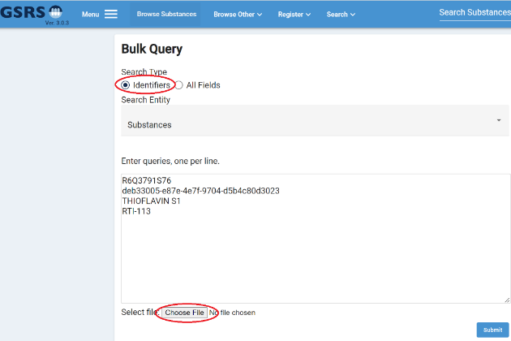

Figure 10 - Bulk Search – Search by Identifiers

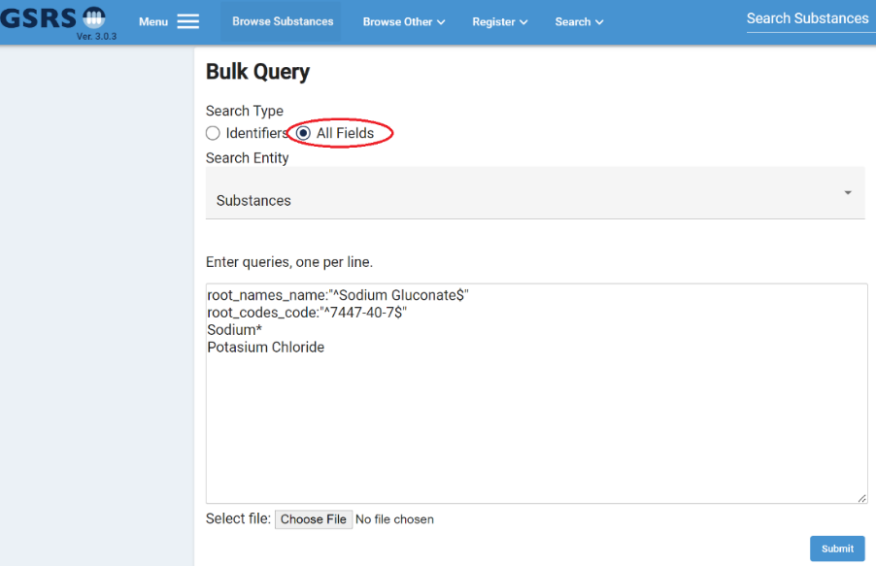

Figure 11- Bulk Search – Search by All Fields

The search results will come back in two parts, search result summary and the search results. Both are paginated. Figure 12 shows an example. The “Display Name” column is clickable. It will direct users to the set of records that matches the query. Users can export the summary result by clicking the “Download Report” button.

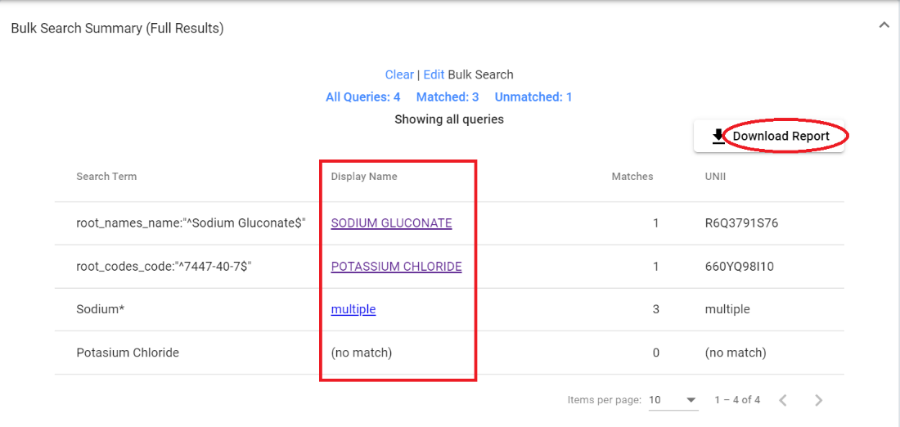

Figure 12 - Bulk Search – Search Result Summary

**Notes for the future:**

In the future release, the bulk search result lists will be associated with users, and they can be saved and updated, or removed. During browsing substances, there will be options to add a substance to a search result list, or to remove it from a list.

## New Feature: UTF8 & HTML Name

**Purpose and Motivation:**

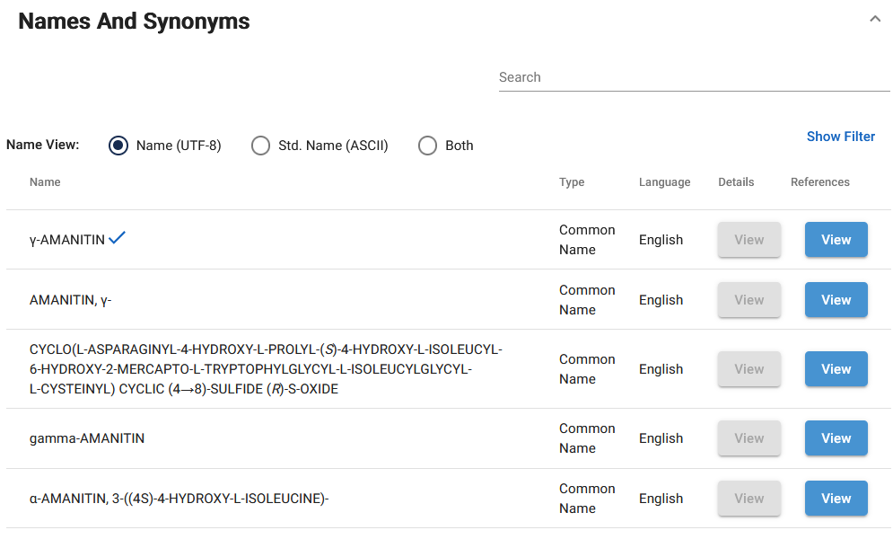

Figure 13 - Names and Synonyms

Initially, GSRS provided support for ASCII text-based names but, as chemical information experts know, substance names commonly include Greek letters, superscripts, italic letters and other non-ASCII characters. With this release, GSRS allows users to enter names that include superscripts, subscripts, small caps and italics as HTML markup, as well as non-ASCII characters.

**How it works:**

When entering a substance name, you can now provide some HTML markup to control display of the name. (For security reasons, we limit the HTML tags we support to: superscript, subscript, italics and small caps.) You can also use Greek letters and other non-ASCII characters.

Provided your database system supports the characters entered (check your database documentation or your database administrator), the characters you entered will be preserved and used in the display of your substance within GSRS.

**Notes for the future:**

We intend to remove HTML tags from standardized names (separate from the main ‘name’ field).

Please let the GSRS team know if you have additional HTML tags in mind.

## New Feature: Frontend DRY allowing custom styling

**Purpose and Motivation:**

Each organization that uses GSRS may wish to customize the appearance and basic assets such as the logo and some key display terms.

**How it works:**

A) We put some basic styling such as header color, link color and button color in a central location. In the angular code base, see the file ‘src/styles/_styles.css’. If you wish for the link color to be different throughout your GSRS instance, change it in the `_styles.css` file. Then, in your angular component’s SCSS file, reference the color variable instead of hard coding a color. For example, this is preferred:

|  |
| --- |
| .mylink {  color: var(--link-color);  } |

B) We made certain frontend substance display term labels configurable. Go to the frontend configuration and find or add this section and for example change “Display Name” to “My Display Name”. Now, “My Display Name” shows as the label on the substance overview and edit pages, amongst other places.

|  |
| --- |
| "elementLabelDisplay": {  "labels": {  "substance_names_name": {  "displayNameTitle": "Display Name",  "displayNameShortTitle":"DN",  "preferredTitle": "Additional Listing Name",  "preferredShortTitle": "AL"  }  } |

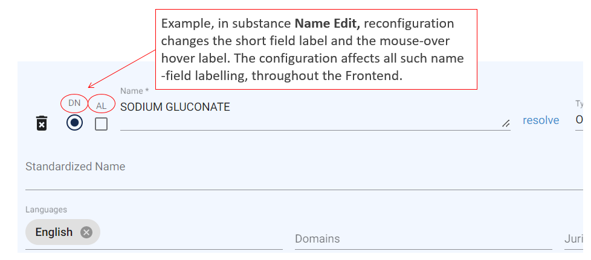

Figure 14 - Frontend Configurable Substance Name Field Labels

**Notes for the Future:**

This is part of an ongoing effort to improve front-end customizability, both with and without requiring a custom build of the front-end.

# Other Issues Addressed

## Improvement: Lucene Upgrade

Description: Lucene is upgraded from 4.10.0 to version 5.5.0.   
NOTE:

Lucene version 5.5.0 has a different format from version 4.10.0. So, we included the *lucene-backward-codecs.jar* in the project. A full reindexing is needed to make it work.

In very rare cases, you may need to remove the whole indexes directory, and then do a full reindexed.

## Improvement: Improved auto-generated SQL indexes

**Description:** To improve performance, extra indexes are added using standard JPA annotations that will allow schema generation to create these database indexes at initialization time. To apply the indexes to an existing database, the “spring.jpa.hibernate.ddl-auto” setting can be set to “update”.

# Other selected Improvements:

* Structure search results are sorted by relevance by default.
* Add database connection info including active connections in health endpoint.
* A StandardNameDuplciateValidator class was added to prevent duplicates names (See the gsrs3-main-deployment/substances application.conf file for example configuration)
* The Frontend menu is more configurable than before. Fewer menu items are hardcoded. See “navItems” in the Frontend config.json file